

**COMPUTER GAME DESIGN**

**CSC4027Z**

**Jam Slam Game Design Document**

**Zenan Shang (SHNZEN001)**

**Erin Heath (HTHERI001)**

**Morten Urstad (UNSMOR001)**

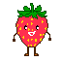

**Jam Slam Game Design Document**

Zenan Shang Erin Heath Morten Urstad

SHNZEN001 HTHERI001 UNSMOR001

[shnzen001@myuct.ac.za](mailto:shnzen001@myuct.ac.za) [htheri001@myuct.ac.za](mailto:htheri001@myuct.ac.za) [unsmor001@myuct.ac.za](mailto:unsmor001@myuct.ac.za)

Players navigate worlds, avoid being killed and overcome obstacles, all the while collecting sugar cubes along the way. The aim of the game is for the characters to make it across the levels and collect enough sugar to use the strawberry and blueberry to create a jam.

1. **Core mechanics:**

*Movement:* The game proceeds with two players playing on a single computer or laptop. The players each take on a distinct character, either the blueberry or strawberry, depending on the computer keys they designate. The keys used include the ‘A’, ‘W’, ‘S’, ‘D’ and space for one character and the up, down, left, right and enter keys for the other character.

The players then navigate through the level using these keys where they need to collect sugar, avoid ants and figure out how to overcome obstacles. The characters need to collect all sugar cubes in order to successfully turn the blueberry and strawberry into jam at the end of the level, but to reach this point, the players need to figure out how to get across the terrain without being killed.

One enemy that is constant throughout the levels is the ants. The strawberry and blueberry avatars are killed if the ants touch them. To prevent this, the players need to avoid the ant by either jumping over them or running away or hiding in the bushes from them. To increase the difficulty of the game, the ants are more attracted to the players as they collect more sugar cubes, causing the ant to detect them more easily and increase the speed at which the ant follows the characters.

The players need to work together in this game to succeed, as if one player dies, they will respawn by dropping from the sky. This is similar to how the players respawn in Pico park. This is making the game easier and able to redo the point of death without travelling long distances.

The players will also need to work together and figure out how to overcome obstacles. They need to use each other to jump onto higher platforms, or complete separate tasks at the same time to be able to move forward in the level. The characters also have different abilities that are enabled if they collect the special brown sugar cube. The players will then have to figure out how to use each of the characters’ special abilities to overcome certain obstacles. The primary ability of each of the characters include the strawberry gaining strength and the blueberry gaining speed. The strawberry can use their ability to push heavy objects and break through walls whereas the blueberry can use their speed to easily cross platforms that fall after being stepped on.

The levels will change as the game progresses, incorporating different scenes and the obstacles will differ according to obstacles one might face in those scenarios. Scenes include farms, the kitchen and a store. We will focus on one environment in this project, the farm, and will include obstacles such as pesticides, relating to the levels’ setting, which can damage the characters and also kill the ants.

1. **Sugar Cubes:**

The sugar cubes are items that need to be collected throughout the level. All of the sugar cubes need to be collected in order to turn the strawberry and blueberry into a jam at the end of the level. A scale item will appear in the top left corner of the game, indicating how many sugar cubes the characters need to collect and how many sugar cubes the characters have collected so far. Once the players reach the end of the level, they will be weighed on a scale and if the required weight is achieved, the blueberry and strawberry are tossed into a cauldron, creating a jam.

There will be two types of sugar cubes, including white sugar cubes and brown sugar cubes. White sugar cubes are the ones that need to be collected throughout the game in order for the strawberry and blueberry to be made into a jam, whereas the brown sugar cubes will be used to upgrade the abilities of the strawberry and blueberry. There will be only one brown sugar cube that will be shared between the characters, increasing the teamwork required to complete the levels. The players can share the sugar cube by the character currently holding the brown sugar cube releasing it, using either the down or ‘S’ key, which the other player can then pick up and use to increase their special ability in order to overcome a certain obstacle.

1. **Game Level / Gameplay Example:**

In "Jam Slam", the level design will revolve around the farm setting, creating an immersive gameplay experience. Each level will be crafted to balance difficulty, teamwork, and fun.

The landscape will not just be flat. Rolling hills, terraced farmlands, and abrupt cliffs will ensure strategic gameplay. There'll be sporadic patches of grass that players can hide behind to avoid ants.  
There’ll also be movable stacks of dirt, utilized by the strawberry's strength to create new paths or block threats.

Here is an example. The Strawberry can’t leave the Blueberry behind, so the Blueberry has to position itself so the Strawberry can jump on top of him, before then pushing the dirt stack making it possible for the Blueberry to get itself up.

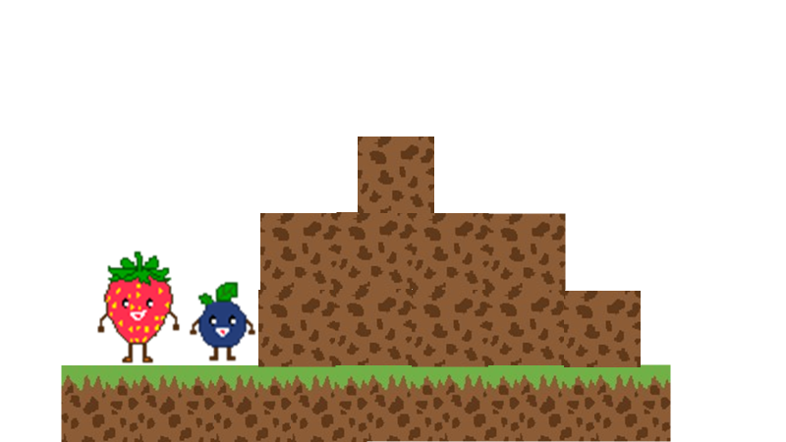

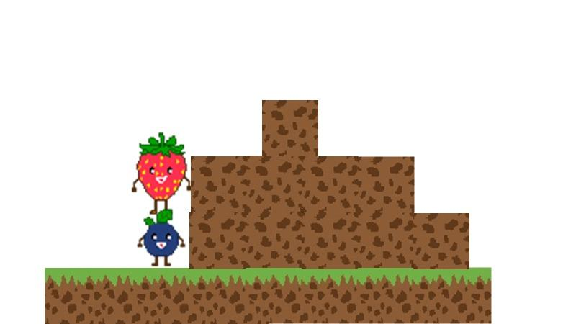

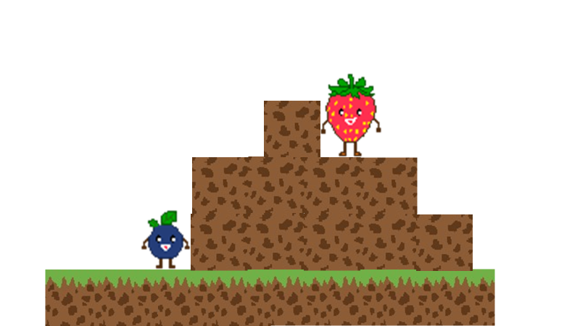

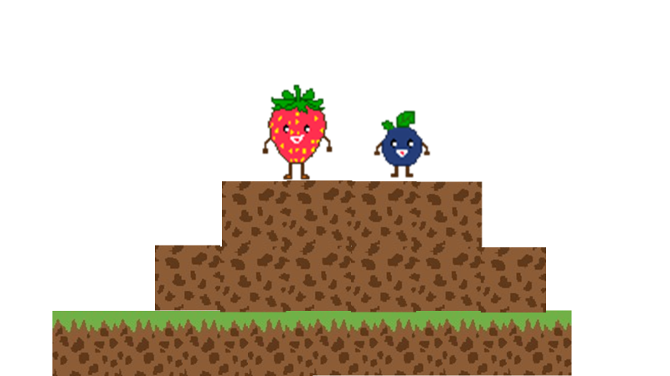

**4. How to finish the level:**

Upon reaching the end of each stage, players will encounter a gate blocking the path to the cauldron – the final objective for the berries to become jam. This gate is linked to a precision scale.

To open the gate, one or both berries must stand on top of the scale. The gate will open only when the total number of sugar cubes on the scale matches the sugarcube requirement. Here are the two methods to open the gate:

* One berry has all the sugarcubes and is standing on the scale
* Both berries stand on the scale with combined sugarcube equal to the scale requirement.

If any of the requirements is not met, the gate remains closed, and the berries cannot proceed to the cauldron.

Each level will have different requirements for the sugarcubes, some may require more sugar cubes than others. However, the total amount of sugar cubes in the level is equal to the total amount of sugar cubes required for the scale. This means that there will not be a situation where there could be more sugar cubes in the level compared to the required sugar cubes.

This is a paper sketch of how the game ends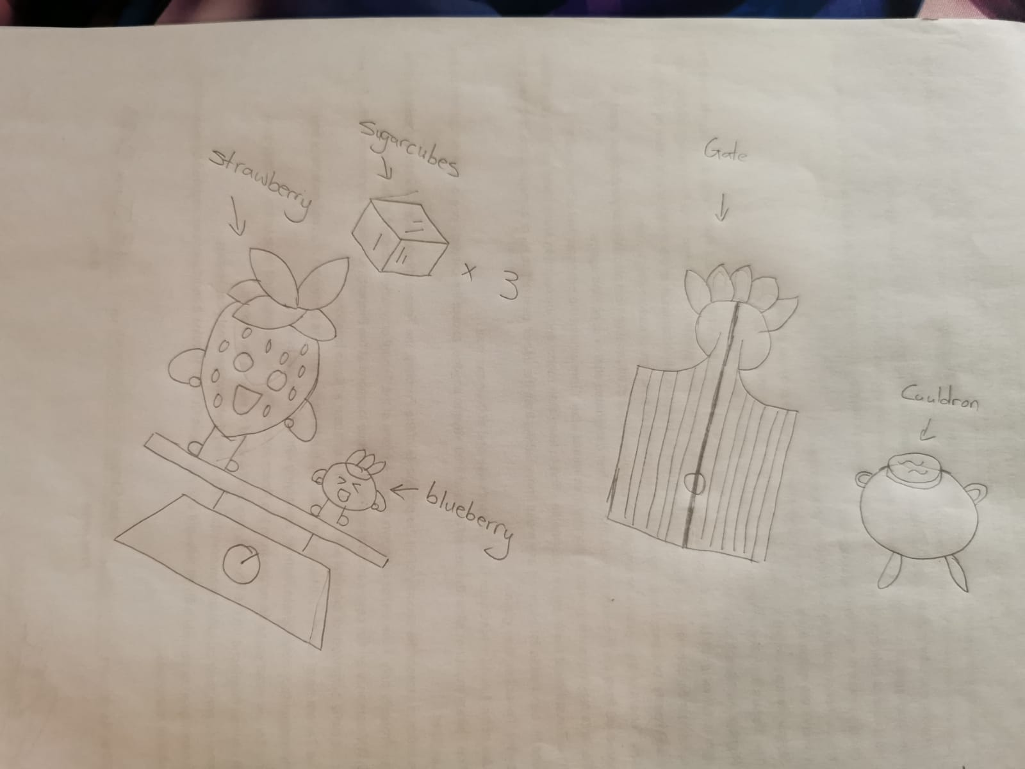

1. **2D Design:**

After some browsing on the Unity Asset Store, we cannot find any free assets on strawberry and blueberries, therefore we decided to design our own berries using the Piskel application. The following pictures are all designed using piskel. All 2D designs will come in resolution of 128 x 128 once we start development.



64 x 64 Image of the Strawberry



40 x 40 image of the blue berry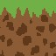

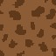

64 x 64 grass

64x64 soil



Water design, we designed three different shapes of waves, in our final product, we will only use one of the design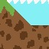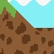

64x64

Cauldron 128 x 128

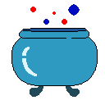

Gate - closed & open 128 x 128

Closed Open

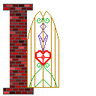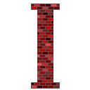

Sugar cubes: 128 x 128

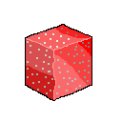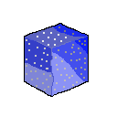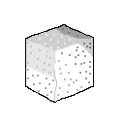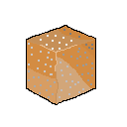

1. **Menu Design** 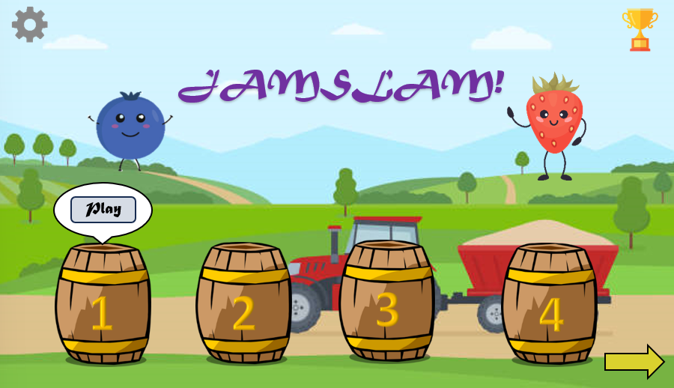

This is a design for the main menu where the user can select the level that they would like to play. The user can scroll to access all levels, however, they will only be able to play the levels that they have unlocked. The user can replay previous levels, however, progress in the level will not be saved and the user will have to restart the level after exiting it. After clicking the barrel, a bubble containing a play button will pop up where the user will have to click play to start the level.

There will also be achievements and setting pages. In the achievements page, the user can see achievements that they have reached as well as possible achievements that they can achieve through playing more levels. The settings page will allow the user to adjust the sound effects of the game.

1. **Future Scope**

We will include more types of sugar cubes, blue and red sugar cubes. Red sugar cubes can only be collected by strawberry and blue sugar cubes can only be collected by blueberry. The special sugar cubes can also have special abilities for the berries. Such as strawberry becomes bigger, blueberry becomes smaller, change in speed or being immune to insects/flies.

We will develop a feature where players can develop their own by drag and drop, they will be able to test their environment and upload the environment to the community where other players can download and play. This would be beneficial for the game level design as we will have a community to develop the game instead of just the developers.

To add more story to the game, we can add chapters to the game. I.e. Chapter 1: Farm, Chapter 2: House, Chapter 3: Kitchen and so on. This adds more elements of fun and uncertainty in the game, making players want to explore and play more.